Class diagram
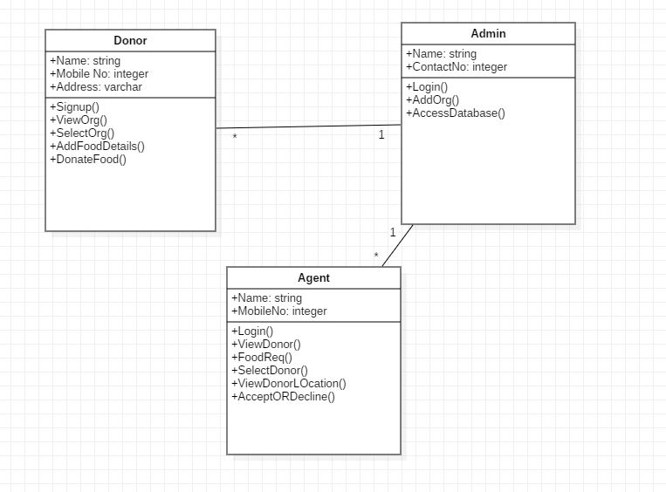

Use case diagram

Sequence diagram

Activity Diagram

Deployment diagram

State chart diagram

Colloboration diagram

Component diagram

